**Name : Nabeeha Ali Rana**

**Section : DS - 3A**

**Roll No : BSDSM - 037**

**AI LAB**

**Task 4**

**1. Luhn Algorithm (Credit Card Validation)**

**How it Works:**

Doubles every second digit from the right (excluding the last digit). If doubled digit > 9, subtracts 9. Sums all resulting digits plus the original last digit. Valid if total is a multiple of 10.

**Why:**

A basic checksum for validating identification numbers, preventing simple input errors.

**Output:**



**2. Remove Punctuation**

**How it Works:**

Iterates through each character in the text. If a character is not found in string.punctuation, it's kept. All kept characters are joined back into a new string.

**Why:**

Essential for cleaning text data in Natural Language Processing (NLP) to ensure words are treated consistently without attached symbols.

**Output;**

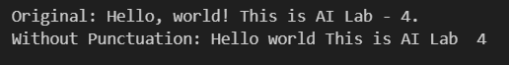

**3. Sort Words Alphabetically**

**How it Works:**

Splits the sentence into words. Uses nested loops (Bubble Sort) to compare adjacent words (case-insensitively) and swap them if they're in the wrong order, until all words are sorted.

**Why:**

Demonstrates the fundamental logic of a sorting algorithm (Bubble Sort) without using built-in sort functions.

**Output:**

